Password Cracking Challenge 2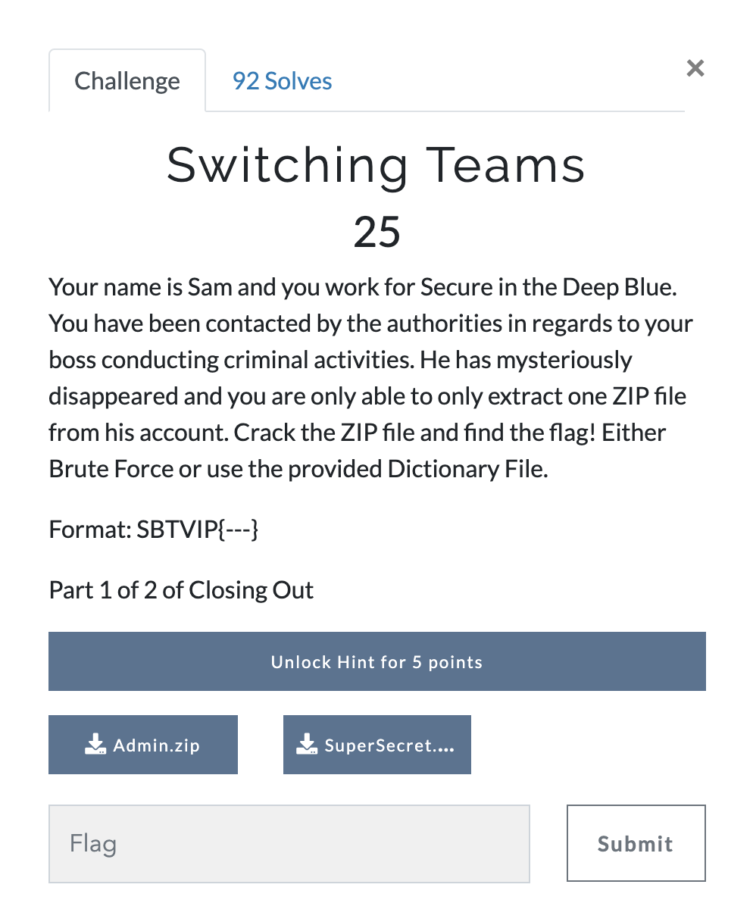
Answer: We have a zip file and and provided dictionary file. The are few ways to solve this one but we’re going to try my favourite method first using johntheripper.
First we need to generate a hash for the zip file. Command: zip2john Admin.zip > AdminPass
Now we have the hash. Let’s finish the off by using john with the rockyou wordlist. Command: john AdminPass --wordlist=rockyou.txt
We have our password, a1b2c3d4, we can now extract everything and read the flag file. John/Flag1.txt
Flag: SBTVIP{Secure_contain_pr0t3ct}
